Diversity of any kind is a wealth
Being respectful and careful of others is always worth it.
By Elsa Cozzi – Children’s Ministries EUD
THE FOX AND THE STORK (Well-known Aesop animals’ tale)
(Foreword for the storyteller: the following story is a famous tale written by Aesop. As many stories, its purpose is to teach life values using animals. Aesop didn’t think on “special needs” application creating this story but, in some way, it can be used to let children (as also adults) understand that, depending on the situations, everyone of us may feel “different” or “disabled” if the environmental/ambient conditions are not appropriate and respectful of everyone. This is the spirit you have to keep in mind as you tell the story and you debrief with children afterwards.)
One day, the Fox thought of a plan to amuse himself at the expense of the Stork, at whose odd appearance he was always laughing.
"You must come and dine with me today," he said to the Stork, smiling to himself at the trick he was going to play. The Stork gladly accepted the invitation and arrived in good time and with a very good appetite.
For dinner the Fox served soup. But it was set out in a very shallow dish, and all the Stork could do was to wet the very tip of his bill. Not a drop of soup could he get. But the Fox lapped it up easily, and, to increase the disappointment of the Stork, made a great show of enjoyment.
The hungry Stork was much displeased at the trick, but he was a calm, even-tempered fellow and saw no good in flying into a rage. Instead, not long afterward, he invited the Fox to dine with him in turn. The Fox arrived promptly at the time that had been set, and the Stork served a fish dinner that had a very appetizing smell. But it was served in a tall jar with a very narrow neck. The Stork could easily get at the food with his long bill, but all the Fox could do was to lick the outside of the jar, and sniff at the delicious odor. And when the Fox lost his temper, the Stork said calmly: Do not play tricks on your neighbors unless you can stand the same treatment yourself.
Moral of this story: The moral drawn is that the “golden rule” of conduct is for one to do to others what one would wish for oneself as it’s written in Matthew 7:12 : “Do to others whatever you would like them to do to you. This is the essence of all that is taught in the law and the prophets.”

Suggested questions for debriefing:
- How could the stork have done differently to teach the fox a better lesson about respect of diversity?
- What would you do if you were in a similar situation? (Being bullied or somebody is amusing him/herself at your expenses)?
- How would you appreciate and enrich your friend’s diversity (culture, religion, ethnicity, social status and diverse mental and physical abilities and so on) ?
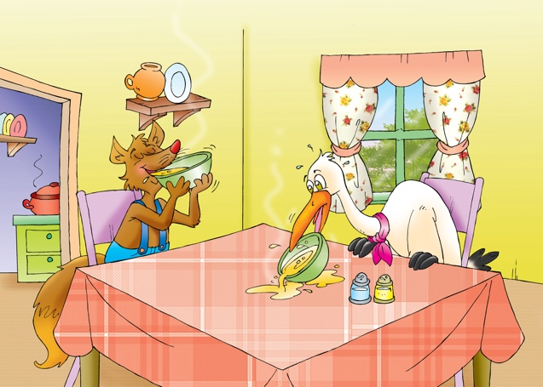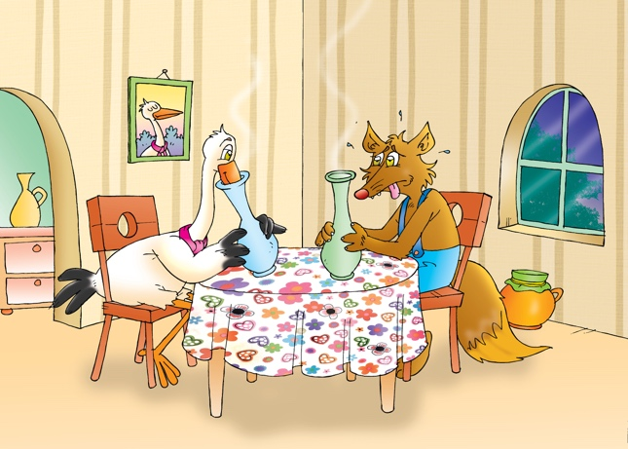
Pictures : ©Shuttterstock

Some thoughts and declarations to think about or to use:

Marabi Amfaal Hydara declared: “Having a disability of any kind should never stop anyone from conquering the world.”
We could rather add to this statement: “Anyone with different abilities may not be considered incapable or inapt if we set up the appropriate context.”

“In the middle of difficult lies opportunity.” (A.Einstein)
“Once we accept our limits, we go beyond them.” (A. Einstein) it is also true that “Once we accept others’ limits, we go beyond them and don’t see them anymore...”

